LAB 8

NAYAKANTI SAI MIHIRNATH - 210905368

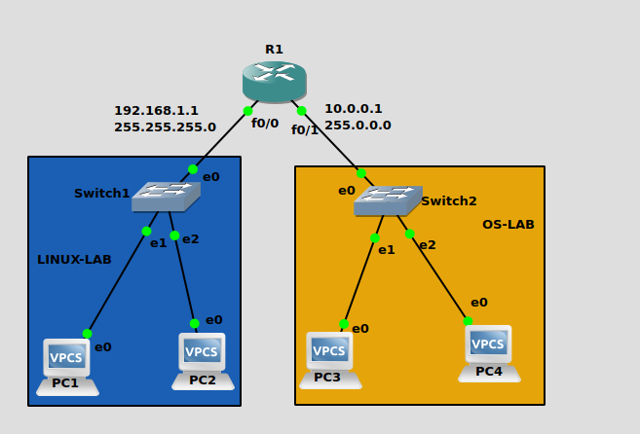

Configuring Router : -

conf t
ip dhcp pool LINUX-LAB
network 192.168.1.0 255.255.255.0
default-router 192.168.1.1
exit

ip dhcp pool OS-LAB
network 10.0.0.0 255.0.0.0
default-router 10.0.0.1
exit

int f0/0
ip address 192.168.1.1 255.255.255.0
no shut
exit

int f0/1
ip address 10.0.0.1 255.0.0.0
no shut
exit
do wr

